VIDEO CHAT APP – NodeJS

What is Node.JS?

Ans Node.js is an open-source and cross-platform JavaScript runtime environment. It is a popular tool for almost any kind of project.

How I can be used in Coding Languages?

Ans Node.js has a unique advantage because millions of frontend developers that write JavaScript for the browser are now able to write the server-side code in addition to the client-side code without the need to learn a completely different language.

How can we do activities using Node.js

Ans

1. Create an empty NodeJS project. Create a new directory called video-chat-app and navigate into this directory.

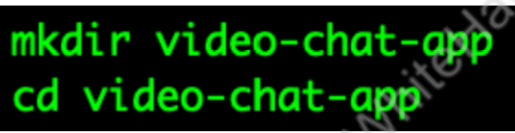

1. To create an empty project template for NodeJS, we can run the following command –

